Course Description: In this course we will go over operations such as conditional formatting, utilizing VLOOKUP and IF STATEMENT functions, charting and graphing data, pivot tables, and other advanced excel topics.

Contents

Course Description: 1

Excel Shortcuts 3

Auto Fill Options 4

Go to 5

Go To Special 6

How to select empty cells in Excel worksheets (Bespalaya, 2016) 6

Manipulating Data 9

Subtotal 11

Text to Columns 12

Remove Duplicates 12

Named Ranges 13

Name a cell 13

Define names from a selected range 13

Use names in formulas 13

Manage names in your workbook with Name Manager 13

Excel Tables 14

Formulas 15

Relative/Absolute/Mixed References 15

IF function 15

SUMIF function 16

COUNTIF function 16

VLOOKUP function 17

INDEX and MATCH Functions Together (Acampora, 2019) 17

Match Function 17

The Index Function 21

Array Formulas 24

How to change Excel calculation options 25

Pivot Tables 26

Charts & Graphs 28

Use slicers to filter data 29

Create a slicer to filter data 29

Slicer components 30

Conditional Formatting 31

Sparklines 31

Add a Sparkline 31

Format a Sparkline chart 32

Use data bars, color scales, and icon sets to highlight data 32

Format cells by using data bars 33

Format cells by using color scales 33

Format cells by using icon sets 34

Data Validation 35

Protect Worksheet 36

# Excel Shortcuts

* Ctrl + A = Select whole Sheet
* Ctrl + Down = moves selection to bottom of data in column (will stop at blanks in column)
* Ctrl + Up = moves selection to top of data in column (will stop at blanks in columns)
* Ctrl + Right = moves selection to most right of data in column (will stop at blanks in columns)
* Ctrl + Left = moves selection to most left of data in column (will stop at blanks in columns)
* Ctrl + End = moves selection to bottom of in worksheet
* Ctrl+ Home = moves selection to A1
* Ctrl + H = Find and Replace
* Ctrl + G = Go to
* Ctrl + V = Paste
* Ctrl + C = Copy
* Ctrl + X = Cut
* Ctrl +1 = open format cell window
* F4 = absolute/relative cell reference
* F3 = Named ranges for pasting
* F2 = moves curser to end of contents in active cell

**Right Click options**: Include same and more options than readily available in ribbon

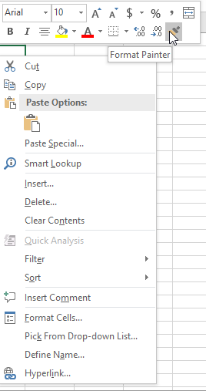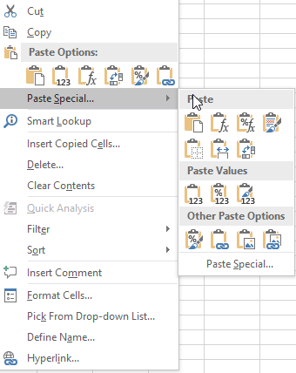

**Format Painter** - copies formatting from one place and applies it to another

**Paste Special**

*  - **Standard paste** (Ctrl+v)
*  - **Paste values** – will paste what you see. Used for pasting values that are coming from a formula
*  - **Paste formulas**: only pastes formulas
*  - **Paste and transpose**: reverses columns and rows
*  - **Paste formatting**: only pastes any formatting and does not change cell content
*  - **Paste link**: pastes a cell value. Used for reference on other worksheets or workbooks

## Auto Fill Options

**Fill Handle** – Drag or double click

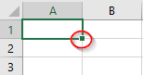

When you use the Fill Handle to pull down a single number or plain text, it will copy the data. When you use the Fill Handle to pull down a text with numbers, a date, a month or a weekday it will fill in a series.

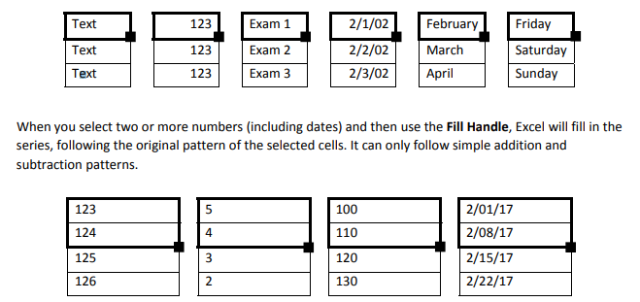

**Auto Fill Option** – This appears after you drag or double click data using the fill handle.

**Copy Cells** – copies and fills cells with data from initial cell selection

**Fill Series** – complete a series, such as 1, 2, 3, 4…

**Fill Formatting Only** – will only fill the cells with formatting from initial cell selection

**Fill Without Formatting** – copies and fills cells with data from initial cell selections without formatting

**Flash fill** - studies the data you enter and the format you use and checks if these data are already in your worksheet. If Flash Fill recognizes these values and grabs the pattern, it offers you a list based on this mode. You can click *Enter* to paste it or ignore the offer

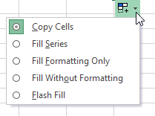

## Go to

A way to travel through the workbook by cell reference or named ranges

Keyboard shortcut = Ctrl + G

Or Home ribbon Find & Select

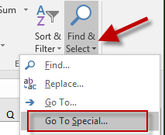

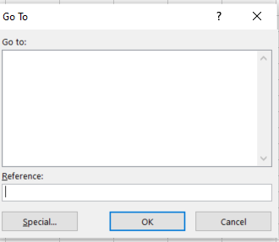

## Go To Special

* Easily fill in blanks in a column
* Select only visible cells for copying

### How to select empty cells in Excel worksheets (Bespalaya, 2016)

Before filling in blanks in Excel, you need to select them. If you have a large table with dozens of blank blocks scattered throughout the table, it will take you ages to do it manually. Here is a quick trick for selecting empty cells.

1. Pick the columns or rows where you want to fill in blanks.  
   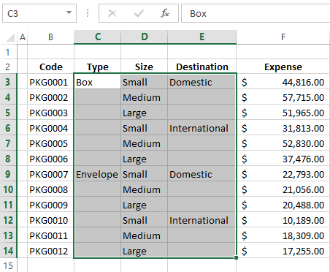
2. Press Ctrl + G or F5 to display the *Go To* dialog box.
3. Click on the *Special* button.

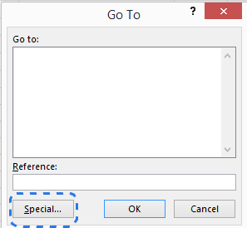

**Note.** If you happen to forget the keyboard shortcuts, go to the *Editing* group on the *HOME* tab and choose the *Go To Special* command from the *Find & Select* drop-down menu. The same dialog window will appear on the screen.

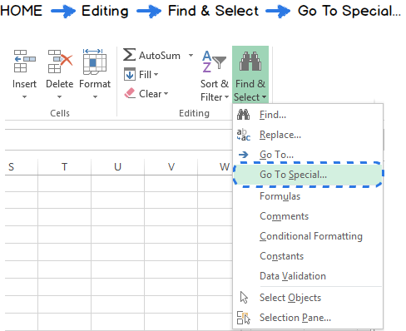

The *Go To Special* command allows you to select certain types of cells such as ones containing formulas, comments, constants, blanks and so on.

1. Select the *Blanks* radio button and click *OK.*  
   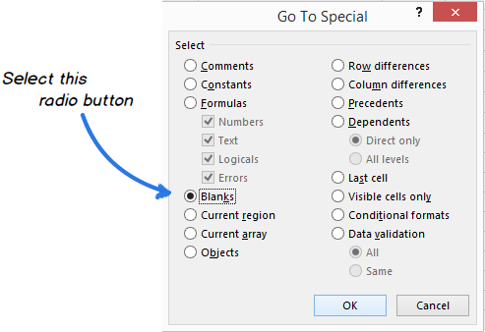
2. Now only the empty cells from the selected range are highlighted and ready for the next step.  
   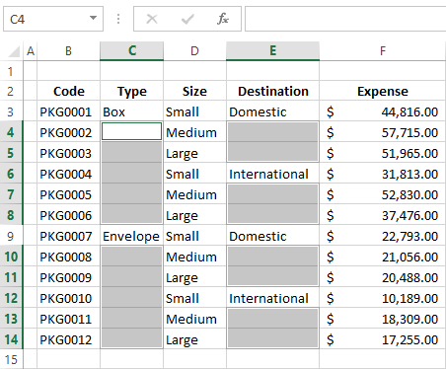

# Manipulating Data

* Sort – You can sort data by text (A to Z or Z to A), numbers (smallest to largest or largest to smallest), and dates and times (oldest to newest and newest to oldest) in one or more columns. You can also sort by a custom list you create (such as Large, Medium, and Small) or by format, including cell color, font color, or icon set.

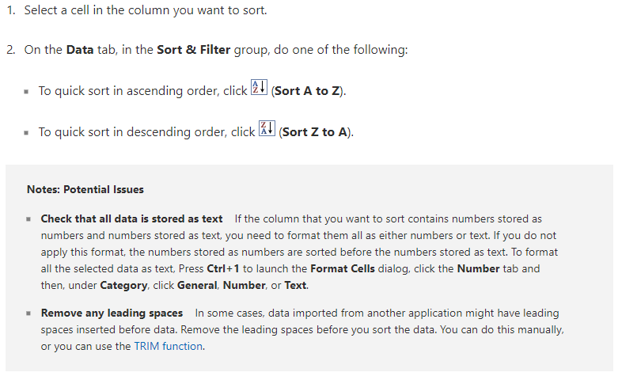

Filter – Use filters to temporarily hide some of the data in a table, so you can focus on the data you want to see.

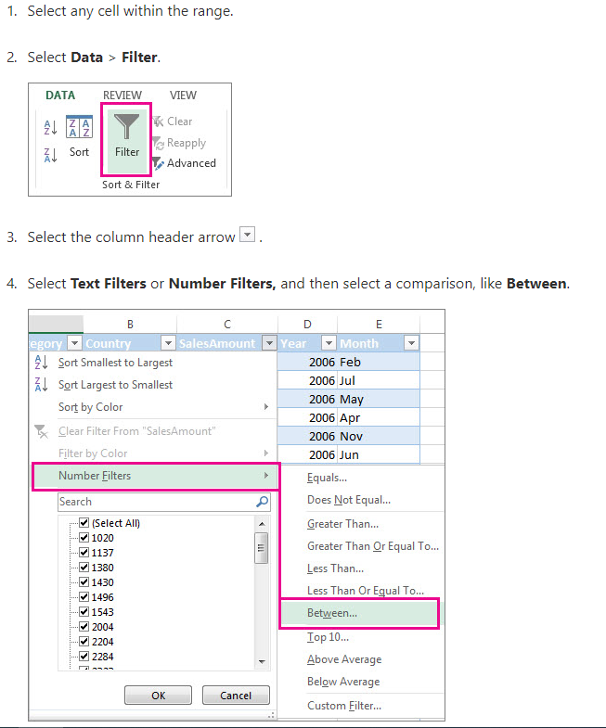

## Subtotal

Returns a subtotal in a list or database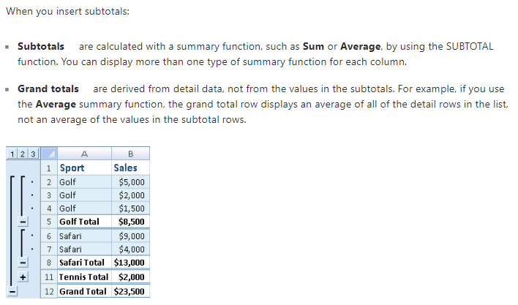

## Text to Columns

Separate the contents of one Excel cell into separate columns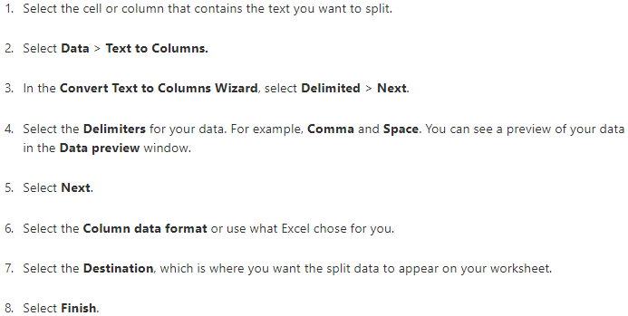

## Remove Duplicates

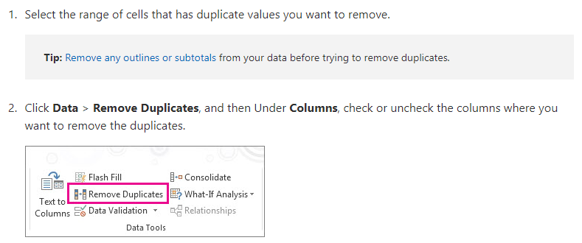

## Named Ranges

By using names, you can make your formulas much easier to understand and maintain. You can define a name for a cell range, function, constant, or table. Once you adopt the practice of using names in your workbook, you can easily update, audit, and manage these names.

### Name a cell

1. Select a cell.
2. In the **Name** Box, type a name.

name box

1. Press Enter.

### Define names from a selected range

1. Select the range you want to name, including the row or column labels.
2. Select **Formulas** > **Create from Selection.**
3. In the **Create Names from Selection** dialog box, designate the location that contains the labels by selecting the **Top row,Left column**, **Bottom row**, or **Right column** check box.
4. Select **OK**.

Excel names the cells based on the labels in the range you designated.

### Use names in formulas

1. Select a cell and enter a formula.
2. Place the cursor where you want to use the name in that formula.
3. Type the first letter of the name, and select the name from the list that appears.

Or, select **Formulas** > **Use in Formula** and select the name you want to use.

1. Press Enter.

### Manage names in your workbook with Name Manager

1. On the Ribbon, go to **Formulas > Defined Names** > **Name Manager**. You can then create, edit, delete, and find all the names used in the workbook.

## Excel Tables

You can create as many tables as you want in a spreadsheet.

To quickly create a table in Excel, do the following:

1. Select the cell or the range in the data.
2. Select **Home** > **Format as Table**.
3. Pick a table style.
4. In the **Format as Table** dialog box, select the checkbox next to **My table as headers** if you want the first row of the range to be the header row, and then click **OK**.

Advantages:

* **Using structured references**    Instead of using cell references, such as A1 and R1C1, you can use structured references that reference table names in a formula. For more information, see [Using structured references with Excel tables](https://support.office.com/en-us/article/using-structured-references-with-excel-tables-f5ed2452-2337-4f71-bed3-c8ae6d2b276e).
* Ensuring data integrity     You can use the built-in data validation feature in Excel. For example, you may choose to allow only numbers or dates in a column of a table. For more information on how to ensure data integrity, see [Apply data validation to cells](https://support.office.com/en-us/article/apply-data-validation-to-cells-29fecbcc-d1b9-42c1-9d76-eff3ce5f7249).

# Formulas

## Relative/Absolute/Mixed References

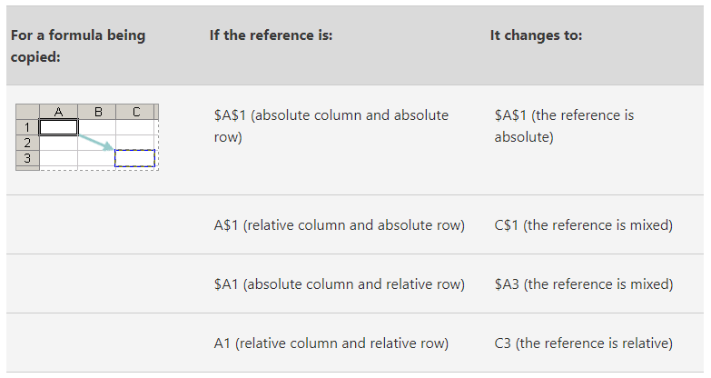CONCATENATE The CONCATENATE function joins two or more text strings into one string.

Syntax: **CONCATENATE(text1, [text2], ...)**

For example:

* =CONCATENATE("Stream population for ", A2, " ", A3, " is ", A4, "/mile.")
* =CONCATENATE(B2, " ",C2)

## IF function

The IF function is one of the most popular functions in Excel, and it allows you to make logical comparisons between a value and what you expect.

So an IF statement can have two results. The first result is if your comparison is True, the second if your comparison is False.

For example, =IF(C2=”Yes”,1,2) says IF(C2 = Yes, then return a 1, otherwise return a 2).

**Note:** If you are going to use text in formulas, you need to wrap the text in quotes (e.g. “Text”). The only exception to that is using TRUE or FALCE, which Excel automatically understands.

## SUMIF function

You use the SUMIF function to sum the values in a range that meet criteria that you specify. For example, suppose that in a column that contains numbers, you want to sum only the values that are larger than 5. You can use the following formula: =SUMIF(B2:B25,">5")

SUMIF(range, criteria, [sum_range])

The **SUMIF** function syntax has the following arguments:

* **range**   Required. The range of cells that you want evaluated by criteria. Cells in each range must be numbers or names, arrays, or references that contain numbers. Blank and text values are ignored. The selected range may contain dates in standard Excel format (examples below).
* **criteria**   Required. The criteria in the form of a number, expression, a cell reference, text, or a function that defines which cells will be added. For example, criteria can be expressed as 32, ">32", B5, "32", "apples", or TODAY().

**Important:** Any text criteria or any criteria that includes logical or mathematical symbols must be enclosed in double quotation marks (**"**). If the criteria is numeric, double quotation marks are not required.

* **sum_range**   Optional. The actual cells to add, if you want to add cells other than those specified in the ***range*** argument. If the ***sum_range*** argument is omitted, Excel adds the cells that are specified in the ***range*** argument (the same cells to which the criteria is applied).
* You can use the wildcard characters—the question mark (**?**) and asterisk (**\***)—as the ***criteria*** argument. A question mark matches any single character; an asterisk matches any sequence of characters. If you want to find an actual question mark or asterisk, type a tilde (**~**) preceding the character.
* *Note: If you want to sum based on multiple criteria, use the SUMIFS function*

## COUNTIF function

Use COUNTIF to count the number of cells that meet a criterion; for example, to count the number of times a particular city appears in a customer list.

In its simplest form, COUNTIF says:

=COUNTIF(Where do you want to look?, What do you want to look for?)

*Note: If you want to count based on multiple criteria, use the COUNTIFS function*

## VLOOKUP function

Use VLOOKUP when you need to find things in a table or a range by row. For example, look up a price of an automotive part by the part number, or find an employee name based on their employee ID.

In its simplest form, the VLOOKUP function says:

=VLOOKUP(What you want to look up, where you want to look for it, the column number in the range containing the value to return, return an Approximate or Exact match – indicated as 1/TRUE, or 0/FALSE).

There are four pieces of information that you will need in order to build the VLOOKUP syntax:

1. The value you want to look up, also called the lookup value.
2. The range where the lookup value is located. Remember that the lookup value should always be in the first column in the range for VLOOKUP to work correctly. For example, if your lookup value is in cell C2 then your range should start with C.
3. The column number in the range that contains the return value. For example, if you specify B2:D11 as the range, you should count B as the first column, C as the second, and so on.
4. Optionally, you can specify TRUE if you want an approximate match or FALSE if you want an exact match of the return value. If you don't specify anything, the default value will always be TRUE or approximate match.

Now put all of the above together as follows:

=VLOOKUP(lookup value, range containing the lookup value, the column number in the range containing the return value, Approximate match (TRUE) or Exact match (FALSE)).

## INDEX and MATCH Functions Together (Acampora, 2019)

### Match Function

The MATCH function is really like VLOOKUP's twin sister (or brother).  Its job is to look through a range of cells and find a match. The **difference is that it returns a row or column number**, NOT the value of a cell.

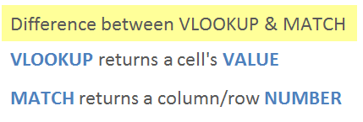

The following image shows the Excel definition of the MATCH function, and then my simple definition.  This simple definition just makes it easier for me to remember the three arguments.

[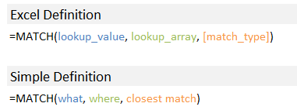](https://www.excelcampus.com/wp-content/uploads/2014/05/Match-Simple-Definition.png)

The MATCH function's arguments are also similar to VLOOKUP's.  MATCH's **lookup_array argument is a single row/column**. Therefore, we don't need the column index number argument that VLOOKUP requires.

=MATCH(lookup_value, lookup_array, [match_type])

=VLOOKUP(lookup_value, table_array, col_index_number, [range_lookup])

Let's dive into an example to see how MATCH works.

We'll use my Starbucks menu example to learn MATCH.  In this case, we want to use the MATCH function to **return the row number** for “Caffe Mocha” from the list of items in column A.

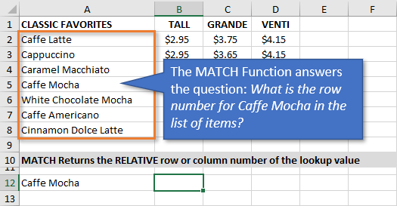

Here are instructions on how to write the MATCH formula.

**1. lookup_value** – The “**what”**argument

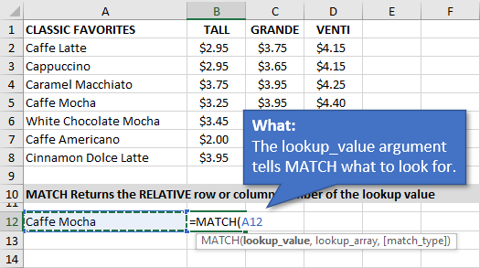

In the first argument, we tell MATCH **what we are looking for**.  In this example, we are looking for “Caffe Mocha” in column A.  I have entered the text “Caffe Mocha” in cell A12 and referenced the cell in the formula.

**2. lookup_array** – The “**where”** argument.

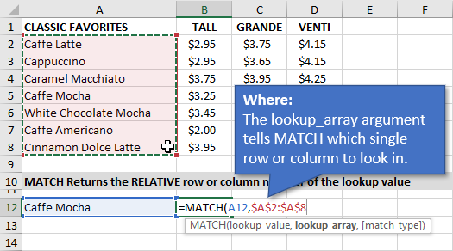

Next, we need to tell MATCH **where** to look for the lookup value.  I selected the range $A$2:$A$8, which contains the list of items.  MATCH will look through this column from **top-to-bottom** until it finds a match.

I made this an **absolute reference** (F4 on the keyboard) so that the range does not change if we copy the formula down. It's good to get in the habit of doing this after selecting the lookup_array range.

Note: You can also specify a row for this argument.  In that case, MATCH would look across the column from **left-to-right** to find a match.

**3. [match_type]** – The “closest/exact” match argument

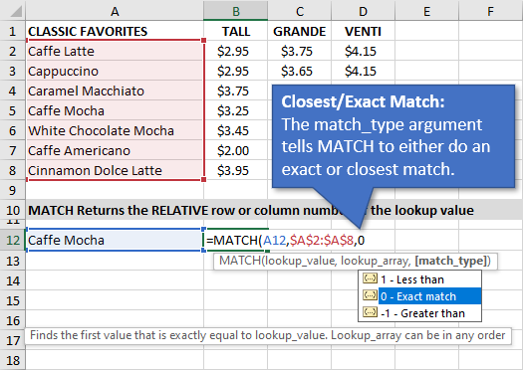

Here we specify if the function should look for an exact MATCH, or a value that is less than or greater than the lookup_value.

MATCH defaults to 1 – Less than. So we always need to specify a 0 (zero) for an exact match. This is similar to specifying FALSE or 0 (zero) for the last argument in VLOOKUP.

When your MATCH is looking up text you will generally want to look for an exact match.

If you are looking up numbers with the MATCH function then the “Less than” or “Greater than” match types can be very useful for [tax and commission rate calculations](https://www.excelcampus.com/functions/calculate-commissions-vlookup/).

**The Result**

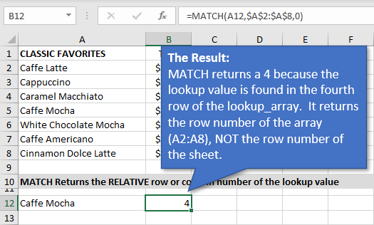

The MATCH function returns a 4. This is because it finds the lookup value in the **4th row of the lookup_array** (A2:A8).

It's important to note that this is **NOT the row number of the sheet**. The row/column number that MATCH returns is relative to the lookup_array (range).

Now that we have a basic understanding of how MATCH works, let's see how INDEX fits in.

### The Index Function

The [INDEX function is like a roadmap for the spreadsheet](https://www.excelcampus.com/functions/index-function-explained/). It returns the value of a cell in a range based on the row and/or column number you provide it.

There are three arguments to the INDEX function.

=INDEX(**array**, **row_num**, **[column_num]**)

The third argument [column_num] is optional, and not needed for the VLOOKUP replacement formula.

So, let’s look at the Starbucks menu again and answer the following question using the INDEX function.

**“What is the price of the Caffe Mocha, size Grande?”**

**1. array** – The “**where”**argument.

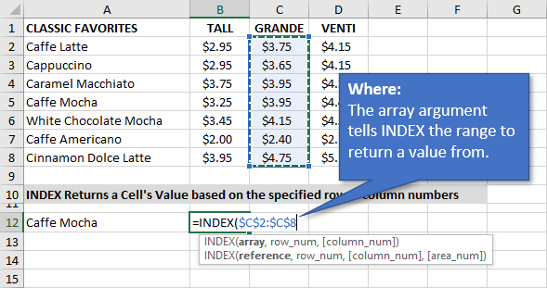

This argument tells the INDEX where to look in the spreadsheet.  I specified $C:$2:$C$8 because this range is the **column of prices that I want to return a value from**.

Again, it's good practice to make this range an ***absolute reference*** so you can copy the formula down.

**2. row_num** – The “row number” argument

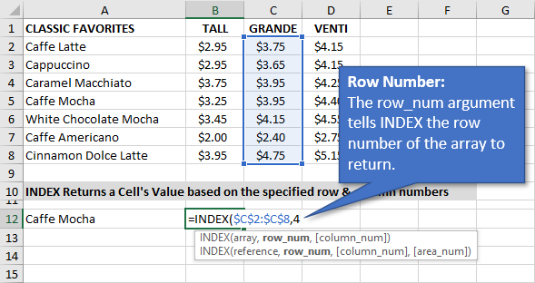

Next, we **specify the row number** of the value we want to return within the array (range). This is the row number of the array, NOT the row number of the sheet.

For now, we can hard code this number by typing a **4** into the formula.

The Result

The result is $3.95, the value in the 4th cell of the array (range).

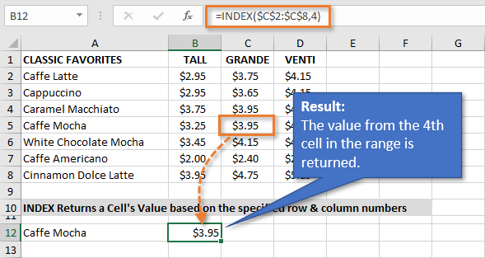

**Important Note:** The number formatting from the array range does not automatically get applied to the cell that contains the formula. If you see a 4 returned by INDEX, this means you need to apply a number format with decimal places to the cell(s) with the formula.

INDEX is pretty simple on its own.  Let's see how to combine it with MATCH.

#### Combining INDEX and MATCH

By **combining the INDEX and MATCH functions**, we have a comparable replacement for VLOOKUP.

To write the formula combining the two, we use the MATCH function to for the row_num argument.

In the example above I used a 4 for the row_num argument for INDEX. We can just replace that with the MATCH formula we wrote.

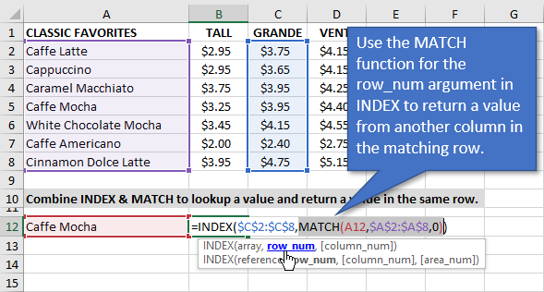

The MATCH function returns a 4 to the row_num argument in INDEX. INDEX then returns the value of that cell, the 4th row in the array (range).

The result is $3.95, the price of the Caffe Mocha size Grande.

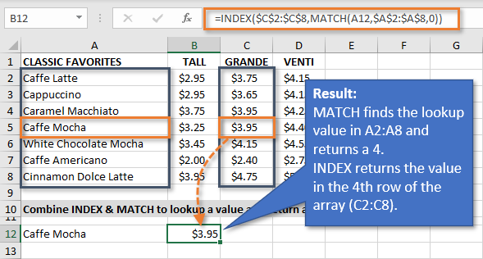

Here is a simple guide to help you write the formula until you've practiced enough to memorize it.

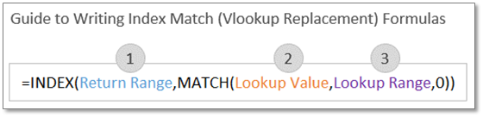

Again, you can think of MATCH as the VLOOKUP. It just returns a row number to INDEX. INDEX then returns the value of the cell in a separate column.

## Array Formulas

Excel for Office 365 Excel for Office 365 for Mac Excel 2019 Excelf 2016 [More...](javascript:)

An array formula is a formula that can perform multiple calculations on one or more items in an array. You can think of an array as a row or column of values, or a combination of rows and columns of values. Array formulas can return either multiple results, or a single result.

Beginning with the September 2018 update for [Office 365](https://products.office.com/en-us/buy/compare-microsoft-office-products), any formula that can return multiple results will automatically spill them either down, or across into neighboring cells. This change in behavior is also accompanied by several new [dynamic array functions](https://support.office.com/en-us/article/dynamic-arrays-and-spilled-array-behavior-205c6b06-03ba-4151-89a1-87a7eb36e531). Dynamic array formulas, whether they’re using existing functions or the dynamic array functions, only need to be input into a single cell, then confirmed by pressing **Enter**. Earlier, legacy array formulas require first selecting the entire output range, then confirming the formula with **Ctrl+Shift+Enter**. They’re commonly referred to as **CSE** formulas.

You can use array formulas to perform complex tasks, such as:

* Quickly create sample datasets.
* Count the number of characters contained in a range of cells.
* Sum only numbers that meet certain conditions, such as the lowest values in a range, or numbers that fall between an upper and lower boundary.
* Sum every Nth value in a range of values.

### How to change Excel calculation options (Cheusheva, 2018)

On the Excel ribbon, go to the Formulas tab > Calculation group, click the **Calculation Options** button and select one of the following options:  
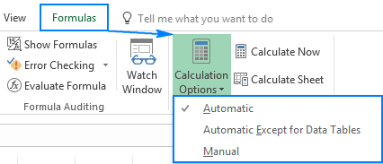

**Automatic** (default) - tells Excel to automatically recalculate all dependent formulas every time any value, formula, or name referenced in those formulas is changed.

**Automatic Except for Data Tables** - automatically recalculate all dependent formulas except data tables.

Please do not confuse Excel Tables (Insert > Table) and Data Tables that evaluate different values for formulas (Data > What-If Analysis > Data Table). This option stops automatic recalculation of data tables only, regular Excel tables will still be calculated automatically.

**Manual** - turns off automatic calculation in Excel. Open workbooks will be recalculated only when you explicitly do so by using one of [these methods](https://www.ablebits.com/office-addins-blog/2017/06/29/excel-calculations-automatic-manual-iterative/#force-recalculation-excel).

# Pivot Tables

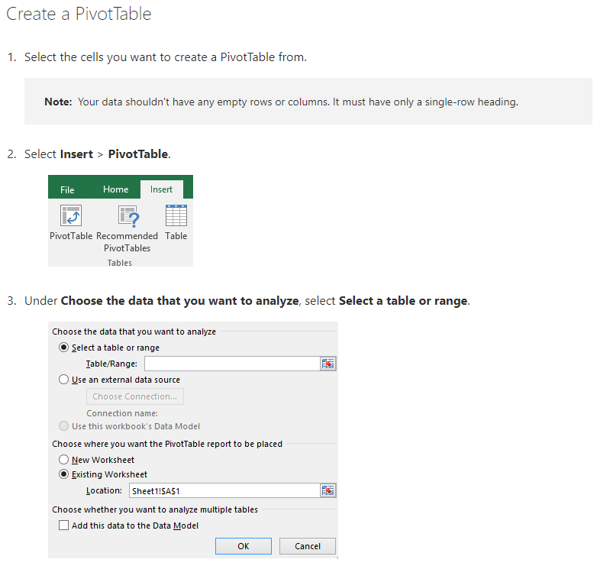

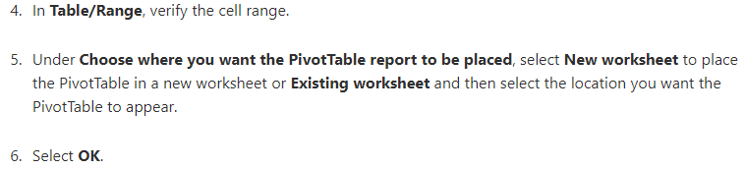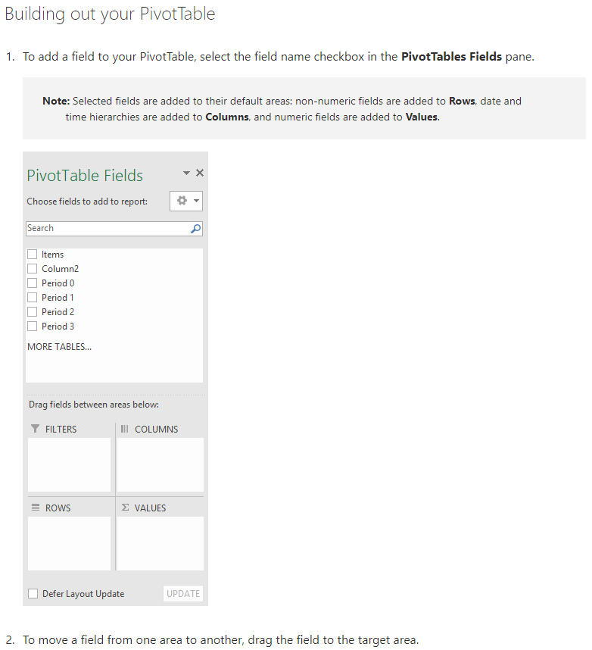

# Charts & Graphs

Charts help you visualize your data in a way that creates maximum impact on your audience.

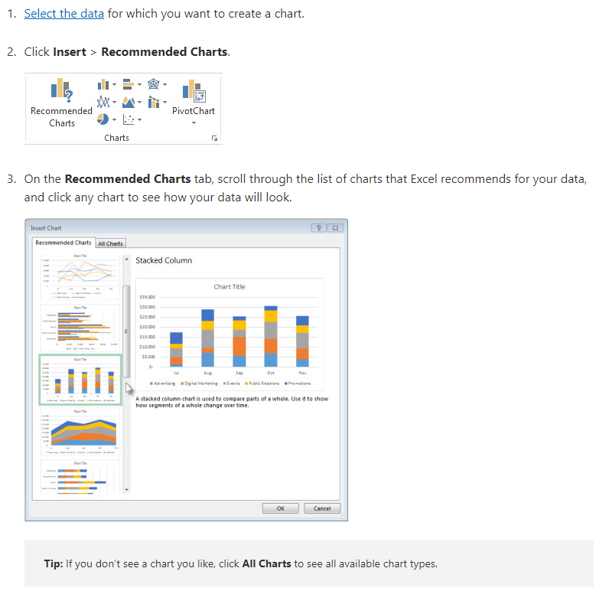

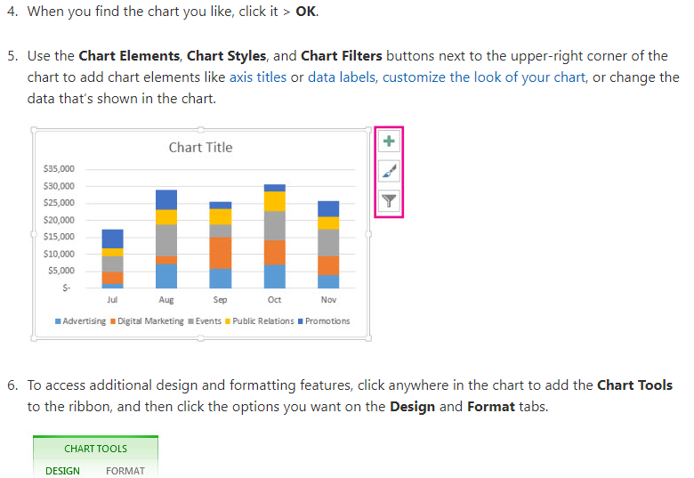

## Use slicers to filter data

Slicers provide buttons that you can click to filter [tables](https://support.office.com/en-us/article/create-and-format-tables-e81aa349-b006-4f8a-9806-5af9df0ac664), or [PivotTables](https://support.office.com/en-us/article/create-a-pivottable-to-analyze-worksheet-data-a9a84538-bfe9-40a9-a8e9-f99134456576). In addition to quick filtering, slicers also indicate the current filtering state, which makes it easy to understand what exactly is currently displayed.

### Create a slicer to filter data

1. Click anywhere in the table or PivotTable.
2. On the **Home** tab, go to **Insert**> **Slicer**.

Insert Slicer

1. In the **Insert Slicers** dialog box, select the check boxes for the fields you want to display, then select **OK**.
2. A slicer will be created for every field that you selected. Clicking any of the slicer buttons will automatically apply that filter to the linked table or PivotTable.
3. You can adjust your slicer preferences in the **Slicer** tab (in newer versions of Excel), or the **Design** tab (Excel 2016 and older versions) on the ribbon.
4. If you want to connect a slicer to more than one PivotTable, go to **Slicer** > **Report Connections** > check the PivotTables to include, then select **OK**.

### Slicer components

A slicer typically displays the following components:

|  |  |
| --- | --- |
| PivotTable slicer elements | 1. A slicer header indicates the category of the items in the slicer.  2. A filtering button that is not selected indicates that the item is not included in the filter.  3. A filtering button that is selected indicates that the item is included in the filter.  4. A **Clear Filter** button removes the filter by selecting all items in the slicer.  5. A scroll bar enables scrolling when there are more items than are currently visible in the slicer.  6. Border moving and resizing controls allow you to change the size and location of the slicer. |

# Conditional Formatting

Conditional formatting quickly highlights important information in a spreadsheet.

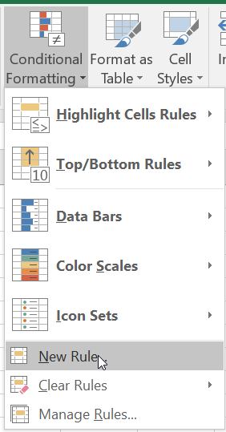

# Sparklines

A sparkline is a tiny chart in a worksheet cell that provides a visual representation of data. Use sparklines to show trends in a series of values, such as seasonal increases or decreases, economic cycles, or to highlight maximum and minimum values. Position a sparkline near its data for greatest impact.

## Add a Sparkline

1. Select a blank cell at the end of a row of data.
2. Select **Insert** and pick Sparkline type, like **Line**, or **Column**.
3. Select cells in the row and **OK** in menu.
4. More rows of data? Drag handle to add a Sparkline for each row.

## Format a Sparkline chart

1. Select the Sparkline chart.
2. Select **Design** and then select an option.  
     
   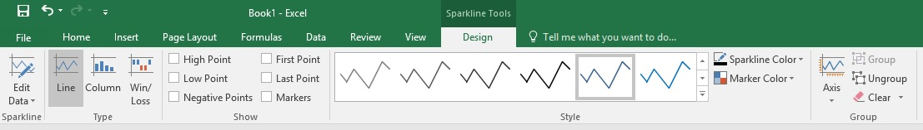
   * Select **Line**, **Column**, or **Win/Loss** to change the chart type.
   * Check **Markers** to highlight individual values in the Sparkline chart.
   * Select a **Style** for the Sparkline.
   * Select **Sparkline Color** and the color.
   * Select **Sparkline Color** > **Weight** to select the width of the Sparkline.
   * Select **Marker Color** to change the color of the markers.
   * If the data has positive and negative values, select **Axis** to show the axis.

# Use data bars, color scales, and icon sets to highlight data

Data bars, color scales, and icon sets are conditional formats that create visual effects in your data. These conditional formats make it easier to compare the values of a range of cells at the same time.

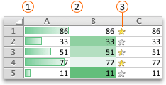

Callout 1Data bars

Callout 2Color scales

Callout 3Icon sets

## Format cells by using data bars

Data bars can help you spot larger and smaller numbers, such as top-selling and bottom-selling toys in a holiday sales report. A longer bar represents a larger value, and a shorter bar represents a smaller value.

1. Select the range of cells, the table, or the whole sheet that you want to apply conditional formatting to.
2. On the **Home** tab, click **Conditional Formatting**.

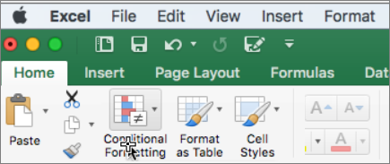

1. Point to **Data Bars**, and then click a gradient fill or a solid fill.

## Format cells by using color scales

Color scales can help you understand data distribution and variation, such as investment returns over time. Cells are shaded with gradations of two or three colors that correspond to minimum, midpoint, and maximum thresholds.

1. Select the range of cells, the table, or the whole sheet that you want to apply conditional formatting to.
2. On the **Home** tab, click **Conditional Formatting**.



1. Point to **Color Scales**, and then click the color scale format that you want.

The top color represents larger values, the center color, if any, represents middle values, and the bottom color represents smaller values.

## Format cells by using icon sets

Use an icon set to present data in three to five categories that are distinguished by a threshold value. Each icon represents a range of values and each cell is annotated with the icon that represents that range. For example, a three-icon set uses one icon to highlight all values that are greater than or equal to 67 percent, another icon for values that are less than 67 percent and greater than or equal to 33 percent, and another icon for values that are less than 33 percent.

1. Select the range of cells, the table, or the whole sheet that you want to apply conditional formatting to.
2. On the **Home** tab, click **Conditional Formatting**.



1. Point to **Icon Sets**, and then click the icon set that you want.

# Data Validation

You can use data validation to restrict the type of data or the values that users enter into a cell. One of the most common data validation uses is to [create a drop-down list](https://support.office.com/en-us/article/create-a-drop-down-list-7693307a-59ef-400a-b769-c5402dce407b).

* Select the cell(s) you want to create a rule for.
* Select **Data >Data Validation**.

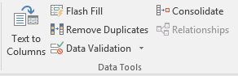

* On the **Settings** tab, under **Allow**, select an option:
  + **Whole Number** - to restrict the cell to accept only whole numbers.
  + **Decimal** - to restrict the cell to accept only decimal numbers.
  + **List** - to pick data from the drop-down list.
  + **Date** - to restrict the cell to accept only date.
  + **Time** - to restrict the cell to accept only time.
  + **Text Length** - to restrict the length of the text.
  + **Custom** – for custom formula.
* Under **Data**, select a condition:
  + **between**
  + **not between**
  + **equal to**
  + **not equal to**
  + **greater than**
  + **less than**
  + **greater than or equal to**
  + **less than or equal to**
* On the **Settings** tab, under **Allow**, select an option:
* Set the other required values, based on what you chose for **Allow** and **Data**. For example, if you select **between**, then select the **Minimum:** and **Maximum:** values for the cell(s).
* Select the **Ignore blank** checkbox if you want to ignore blank spaces.
* If you want to add a **Title** and message for your rule, select the **Input Message** tab, and then type a title and input message.
* Select the **Show input message when cell is selected** checkbox to display the message when the user selects or hovers over the selected cell(s).
* Select **OK**.

Now, if the user tries to enter a value that is not valid, a pop-up appears with the message, “This value doesn’t match the data validation restrictions for this cell.”

# Protect Worksheet

